# deploy servlet in tomcat using local machine

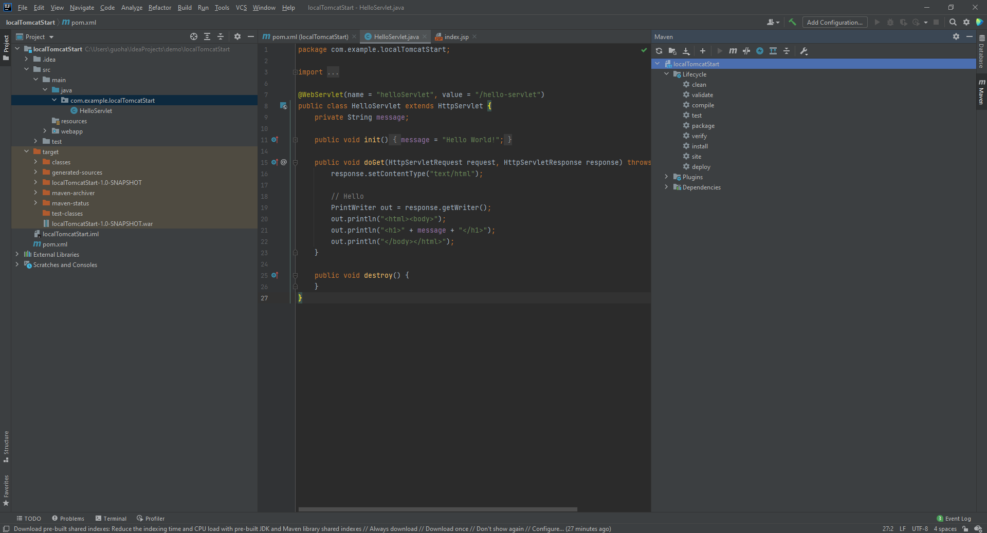

using maven build to create target file, and then find the war file in the file explorer

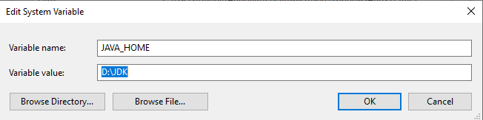

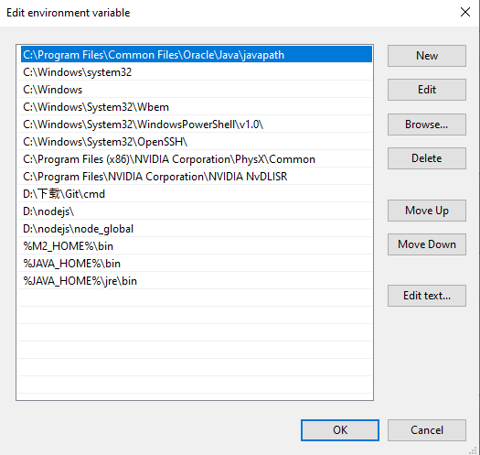

add java home system variable, and path variable like above in order to execute tomcat - startup.bat globally

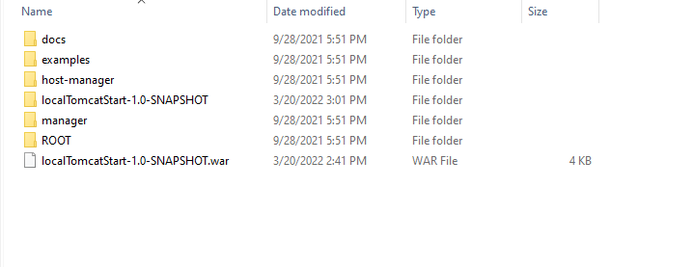

put war file in the tomcat/webapp



execute this bat file in tomcat/bin to start tomcat, then open the browser and type url: localhost:8080/localTomcatStart-1.0-SNAPSHOT